# Java Web Development Basics

# Retake Exam

# Andrey's

Exam for the [“Java Web Development Basics” course @ SoftUni](https://softuni.bg/trainings/2445/java-web-basics-september-2019). Submit your solutions on the course page, so that you can be evaluated by your fellow colleagues.

**Andrey's** is an shop application. There are several requirements you must follow in the implementation.

## Database Requirements

The **Database** of the **Andrey's** application needs to support **2 entities**:

### User

* Has an **Id – UUID-string**
* Has a Username
* Has a Password
* Has an Email

### Product

* Has an **Id – UUID-string**
* Has a Name
* Has a Description
* Has a Price
* Has a Category – option between (Shirt, Denim, Shorts ,Jacket)
* Has a Sex – option between (Male and Female)

Implement the entities with the **correct datatypes** and implement **repositories** for them.

## Page Requirements

### Index Page (logged out user)

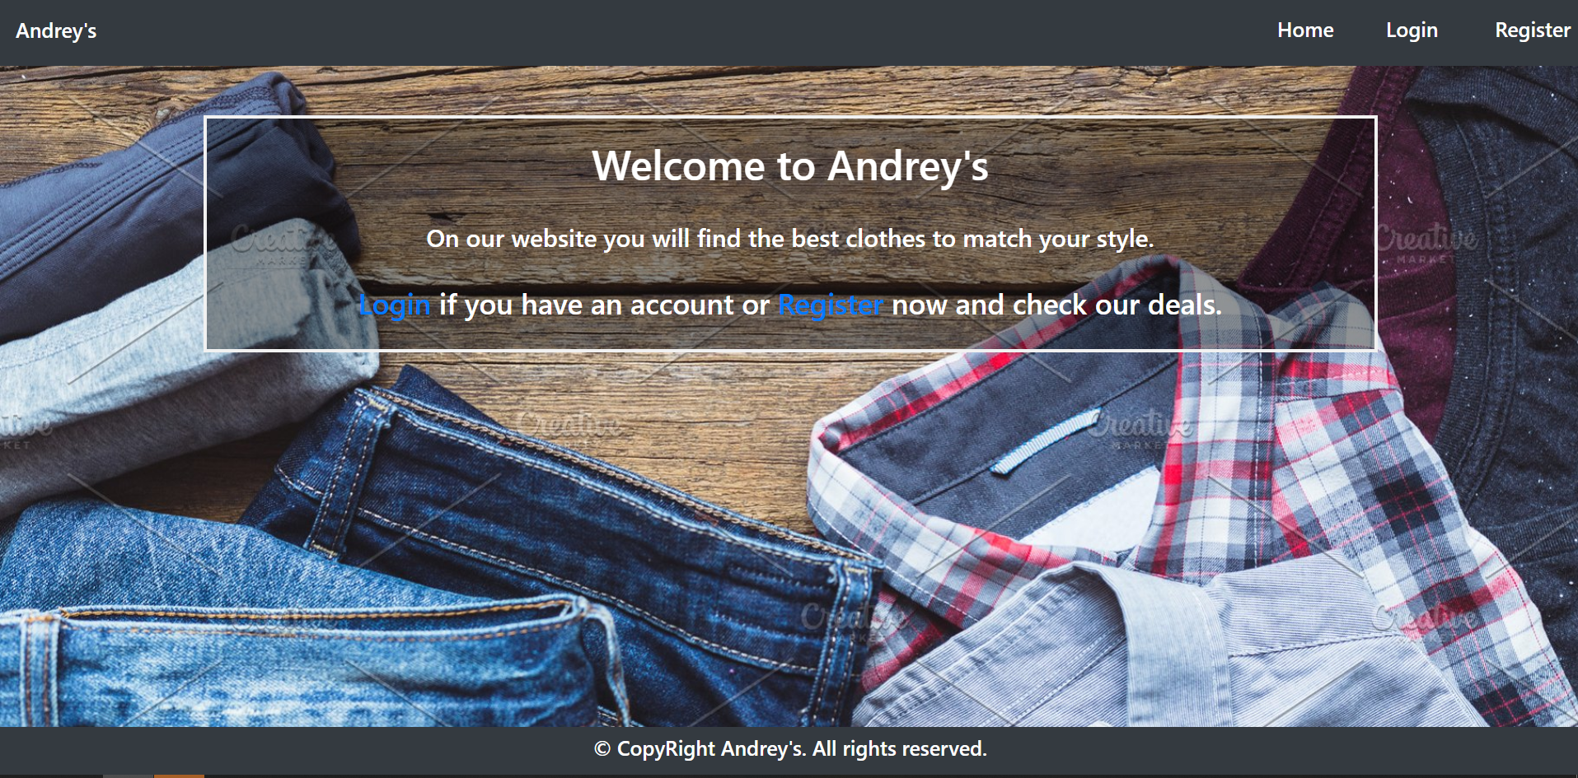

### Login Page (logged out user)

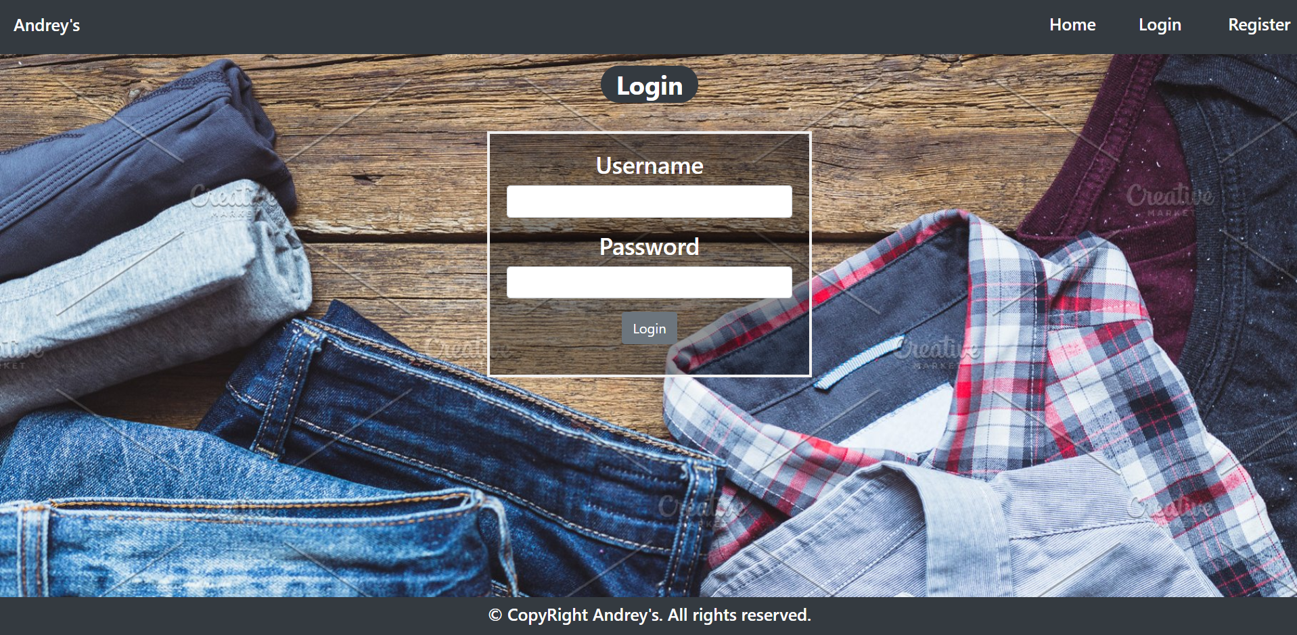

### Register Page (logged out user)

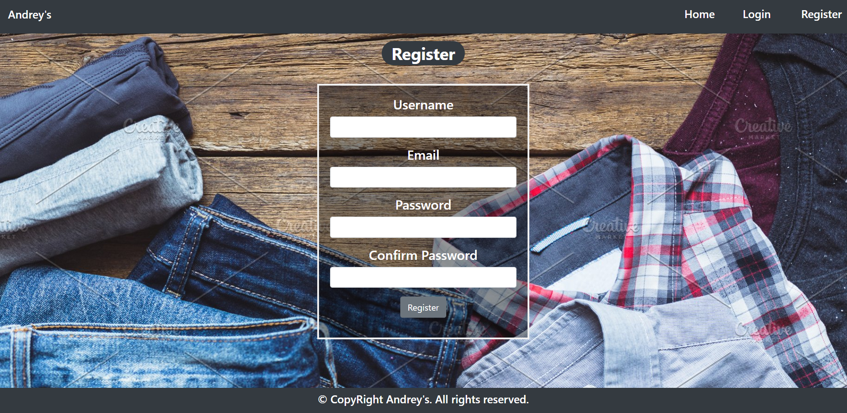

### Home Page (logged in user)

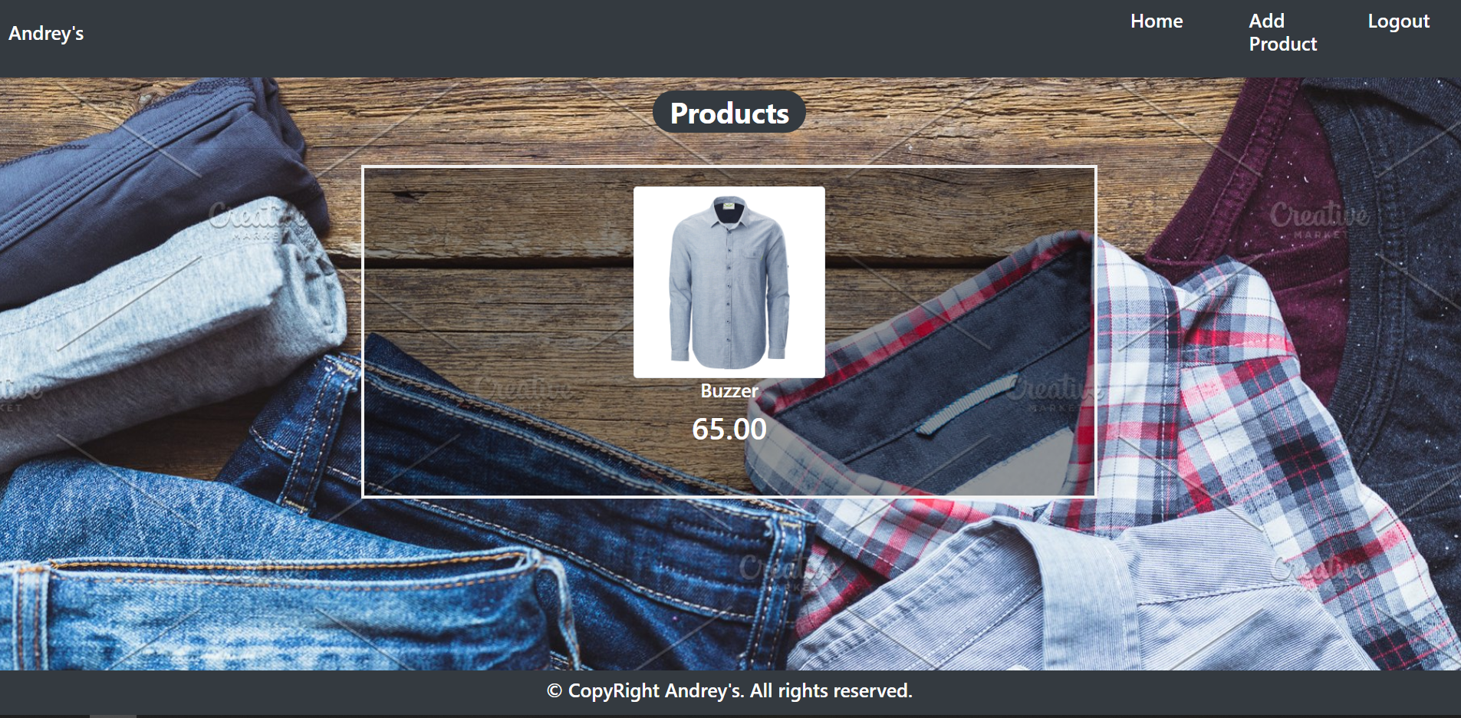

### Add Product (logged in user)

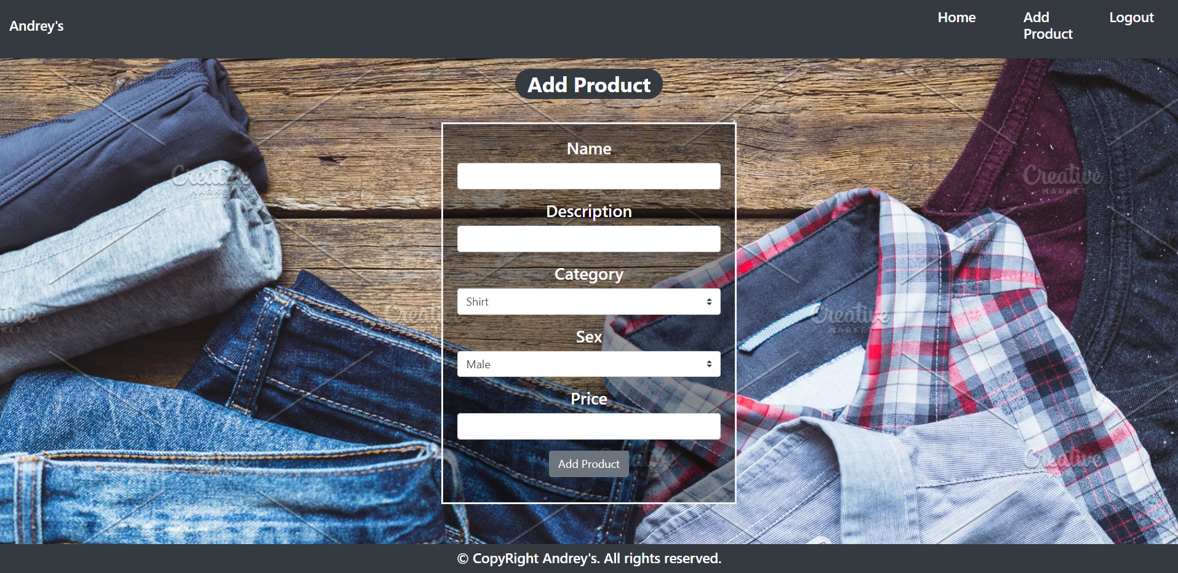

### Product Details Page (logged in user)

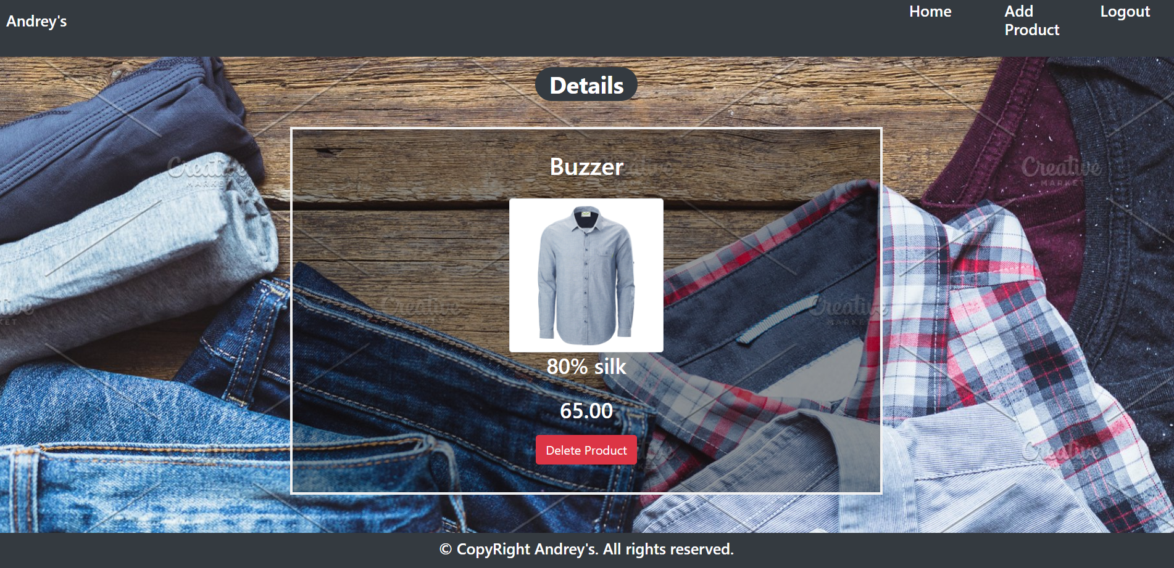

The templates have been given to you in the application skeleton, so make sure you implement the pages correctly.

**NOTE**: The templates should look **EXACTLY** as shown above.

**NOTE**: The templates do **NOT** **require** **additional** **CSS** for you to write. Only **bootstrap** and the **given css** are enough.

## Functional Requirements

The Functionality Requirements describe the functionality that the **Application** must support.

The **application** should provide Guest (not logged in) users with the functionality to login, register and **view** the Index page.

The **application** should provide Users (logged in) with the functionality to logout, **add a Product**, **view** **details** about a Product, **delete** a Product, and **view all** Products(Home page).

**Andray's button** in navbar should redirect to appropriate **URL depending** on that if the user is logged in.

The **application** should provide **functionality** for **adding products** with **category (Shirt, Denim, Shorts, Jacket) and sex(Male,Female)**

The **image** is combination between **category** and **sex**. When you click on the image on **Home** **Page**, you should be redirected to **Details** **page**. On **Details** **page** you should have **Delete** **button**.

The **application** should **store** its **data** into a MySQL database, using Hibernate native.

## Security Requirements

The Security Requirements are mainly access requirements. Configurations about which users can access specific functionalities and pages.

* Guest (not logged in) users can access Index page.
* Guest (not logged in) users can access Login page.
* Guest (not logged in) users can access Register page.
* Users (logged in) can access Home page.
* Users (logged in) can access Product Add page.
* Users (logged in) can access Product Details page.
* Users (logged in) can access Logout functionality.

## Scoring

### Database – 10 points.

### Pages – 30 points.

### Functionality – 40 points.

### Security – 10 points.

### Code Quality – 10 points.